Exit Pass Name:  ϴ  - Label the following triangle  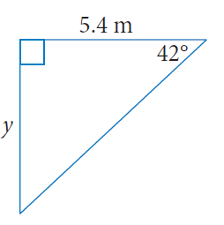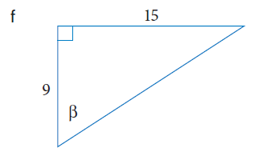 | Exit Pass Name:  ϴ  - Label the following triangle  
Exit Pass Name:  ϴ  - Label the following triangle   | Exit Pass Name:  ϴ  - Label the following triangle  

